LAPTOP REPAIR - VIRAJIT.COM

- Use dark black color for text instead of grey color
- Increase the font size by a least 2 to 4 spaces to make it easy to read

_________________________________________________________________

I do NOT images for this section. So you need to create the one.

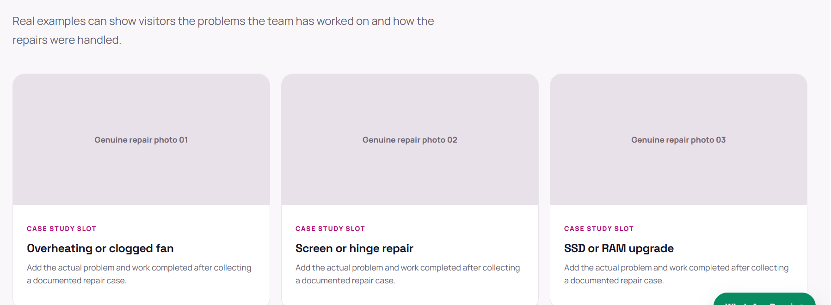

_____________xxx__________________xxx__________________xxx__________

